Title | Has the Staff Innovation Fund achieved what it set out to do?  An evaluation
Author | Michael Keating THT PMO
Date | October 2017
Purpose of the Report | This report provides an initial evaluation of the impact of the Tower Hamlets Together Staff Innovation Fund by addressing the following questions:  - How did the Fund begin?  - Where did the projects take place?  - Have the projects achieved what they set out to do?  - Have the projects made a difference?  - What resources were allocated?  - What have we learned?  Appendix One sets out the details of each project supported by the Fund.
Summary of Key Issues | “Thank you for this opportunity!”  (Project Two)  How did the Fund begin?  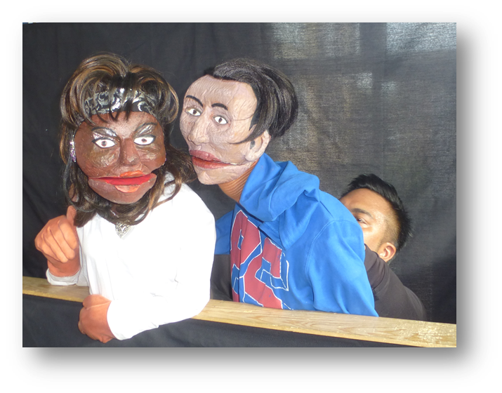  (The view from Project 11)  Following exploration of the idea at the January 2016 staff engagement event, the Staff Innovation Fund was launched using a one-off resource of £300k to encourage the development of service improvement initiatives. The Fund was designed to energise and empower staff by providing opportunities for exploring smaller scale replicable innovations and supporting locally-driven solutions. Proposals had to be delivered in specific teams and locations and demonstrate immediate visible change with a commitment to share learning across the wider system.  Greeted with a great deal of enthusiasm 49 proposals totaling over £1million were submitted for consideration. A panel of senior representatives from four THT partners (Barts Health, East London Foundation Trust, the GP Care Group and LB Tower Hamlets) and a local carer assessed each proposal for its potential to:  - Strengthen integrated health and social care  - Improve the quality and safety of care  - Build more robust partnership working between health and social care and other services  - Explore better ways of working with the voluntary and community sector  - Strengthen the involvement of service users, carers and the wider community, particularly in self-management and prevention initiatives  - Develop new ways of working using information technology, estates and other enablers  - Enhance organisation development and the skills and expertise of the workforce  - Increase efficiency and effectiveness to improve value for money  Following the assessment the panel agreed to support 22 proposals. Three almost immediately decided not to proceed, an additional project withdrew early in 2017 and a further two during the implementation of the new contract for community health services. The Fund has therefore supported 16 projects across THT partners.  A view from Project Thirteen  7/10 children involved strongly agreed they:  - Enjoy eating and preparing healthy food more than they did previously  - Have eaten healthy food taught at the club at home  - Like the doctor’s surgery more now than they did before  In October 2016 at the staff engagement event 11 of the projects explained their work to their peers from across the local health and social care system. As with the initial discussion this ignited tremendous enthusiasm and excitement which was again echoed at a workshop held in March to help develop a report to the Transformation Steering Group.  ‘What have I learned?’ – some reflections from the project leads (March 2017)  - Been hopeful – being hopeful  - Shared experience – reassuring  - Start small and persevere  - Take a risk – believe in yourself  - Letting go of control – trust the group and non-professionals  - Power of bringing people together  - Evidence of messiness and power of innovation  “I felt anxious and depressed, the group helped me get out and do something for myself and have fun.”  (Project Fourteen)  Where did the projects take place?  Although developed across a range of service areas, the majority of projects have taken place in community health services and primary care as outlined in the following table.  Service area Number  Children’s (Royal London) 1  Community health services 5  Mental health and social care 1  Mental health and community arts 1  Primary care 6  Primary care and education 1  Primary care working with external consultant 1  16  These were the service areas where most ideas emerged and may have reflected the stage of THT development at the time of the Fund’s launch.  “I also used the app for my son (15 years old), it is definitely useful for him, he can look at the action plan and make a decision and not panic or decide to call Mum.”  (Project Six)  Have the projects achieved what they set out to do?  Details of each project are provided in Appendix One. Using this it is possible to say that the majority of projects have achieved their aims. At the same time it should be noted that the experience of delivery also modified these aims and opened up other issues for further development.  Aims Project Numbers  Fully achieved Two, Four, Eight, Eleven, Twelve, Thirteen, Eighteen, Nineteen 8  Partially achieved Six, Seven, Fourteen 3  Not achieved Seventeen 1  Too early to say One, Five, Nine, Ten 3  16  Have the projects made a difference?  Each project agreed to submit quarterly reports to assess progress which has also been reported at the THT Workforce and OD workstream and the Transformation Steering Group. The progress reports have been used to categorise the outputs and outcomes into themes as follows:  Themes Project Number  Discovering something new Project Five 1  Increasing knowledge of existing conditions Nine 1  Increasing knowledge by working in partnership with other professionals Two, Eleven, Thirteen 3  Increasing knowledge by working in partnership with service users Fourteen 1  Increasing knowledge by developing a new tool Six 1  Strengthening partnership with other professionals Seven 1  Strengthening partnership with patients and carers One, Eight, Twelve 3  Developing tools to help existing services Four, Ten, Seventeen 3  Increasing knowledge and supporting partnership with patients and carers through the organisation of events Eighteen, Nineteen 2  Total 16  “We have not been to A & E since using the app, so it is all good”  (Project Six)
Risks (and opportunities) | What have we learned?  “I used to be frustrated with asking for help, I now am able to accept my diagnosis and find ways to manage. I tried things in this group that I would never consider trying and was surprised that I actually enjoyed them.”  (Project Fourteen)  Using the initial aspirations of the Fund the following conclusions can be made.  Strengthening integrated health and social care, improving the quality and safety of care and building more robust partnership working between health and social care and other services  - The Fund unleashed tremendous enthusiasm and a range of staff were able to identify interesting and innovative ideas based on their frontline experience  - It seems clear that all projects have provided useful learning for the staff implementing them.  - While it appeared relatively easy to stimulate innovative ideas delivery has proved more difficult for a range of reasons:  - Day-to-day commitments have often diverted resources and limited the space for exploring new practice  - Changes in the system, most obviously the recommissioning of community health services, overtook some of the projects  - Changes in staff, both because of the system change and the inevitable churn of turnover, created either a break in leadership or its disappearance  - Planning was not sufficiently rigorous in all cases and clearly overly optimistic in its aspirations.  - With hindsight, more crossover possibilities could have been identified and encouraged between projects rather than each one operating in relative isolation.  - It appears that the smaller, more contained projects – i.e. using a specific tool or operating in a specific team or practice – proved easier to deliver their aims.  - The projects were subjected to relatively light-touch quarterly monitoring but even this proved difficult for some and required sustained chasing.  - Project management often proved difficult.  - The participation of both staff and service user volunteers was important but also caused further challenges.  - Some projects did raise issues beyond their initial remit, for example an initiative in one practice may have created a greater sense of belonging to the wider local community.  “It’s part of my week, for the first time ever I look forward to something.”  (Project Twelve)  Exploring better ways of working with the voluntary and community sector  - There is little evidence of new relationships being created with the voluntary and community sector (apart from the project led by an external consultant)  - This project faced (and continues to do so) difficulties in accessing the system. This raises questions about whether innovation is constrained to the parts of the system that already know each other.  Strengthening the involvement of service users, carers and the wider community, particularly in self-management and prevention initiatives  - All the projects focused on working with service users were fully or partially successful with some creating exciting new relationships  “Oh mum, I made a salad, I made a salad for you!’’  (Project Thirteen)  Developing new ways of working using information technology, estates and other enablers  - Developing new IT created delays whenever it was required.  - The one project led by an external consultant successfully developed a new tool but found it difficult to gain support from within the system  Find out more about Project Eight  https://vimeo.com/228034501  https://vimeo.com/226274514  https://vimeo.com/226271430  Increasing efficiency and effectiveness to demonstrate value for money  - The additional funding proved a big incentive which means that the work may not have happened otherwise.  - Releasing all the funds took place before some projects began.  - Only one project has been explicit about demonstrating value for money and consequently is now investing its own resources into continuing the work. Two projects have been able to secure additional funds (from public and private sector partners) to sustain their work.  - There is a need for central coordination which was at times resource intensive particularly in the early phases of the Fund.
Financial Implications | A summary of the resources is provided below. Given that some projects have been abandoned there is now an underspend with the potential to provide further support.  Initial fund £300k  Adjustment after 3 projects withdrawn (2016/17) £248k  Outstanding unspent after further withdrawals £42k
Actions being requested | The aims of most projects have been either fully or partially achieved. They have all pointed to further opportunities and are not in themselves an endgame. The challenge for Tower Hamlets Together is to use the experiences of implementing the Staff Innovation Fund to help its next steps. The following recommendations are therefore made:  - The learning from the Fund needs to be incorporated into future organisation development work particularly how to sustain the enthusiasm and desire to innovate as well as the skills to do this productively particularly project management, dealing with volunteers and evaluation.  - Some of the projects are not yet completed so further monitoring will be required.  - There is approximately £42k unspent in the Fund. It is therefore proposed that those projects which have either fully or partially met their aims are asked to submit further bids for how to use some of this to develop their next steps, particularly how their work could be mainstreamed  - It remains important to celebrate the opportunities offered by the Fund and the commitment demonstrated. All projects have been asked to submit a case study describing both successes and failures to facilitate wider learning.  In addition the THT Board is asked to support the commitment and enthusiasm of its staff to explore new ways of working by continuing to provide an innovation fund.
Supporting Documents | Appendix One: overview of projects

Appendix One: overview of projects

“We are very grateful for the grant as it has shown us that this is a cost effective option whilst protecting us from the risks of this innovation and enabling our pharmacist to be trained up in working in GP land and we have realised how there are far more opportunities to use primary care pharmacy than we had initially realised. Thank you!”
(Project One)

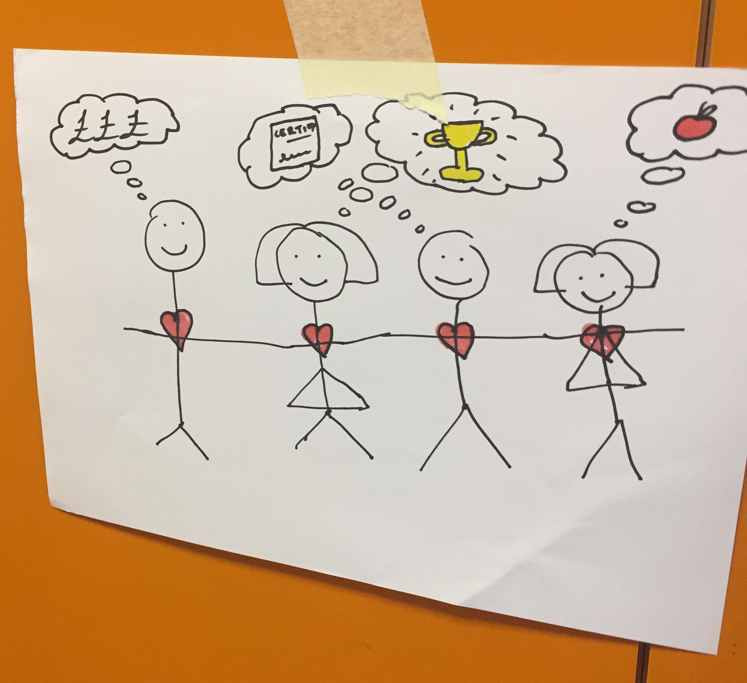

One view of innovation
It saves money, develops skills and opportunities and is better for your health
Result = happy staff and residents

 | Project and lead | Amount | Progress
1. | Support Group for parents and carers of people with learning disabilities and Children’s Therapy Service  Hilary Evans  Lead Occupational Therapist  Community Learning Disability Service | 9,900  (4,950 unspent) | After running a pilot group and developing resources for the future, the OT leading the project left the service in September 2016. As a result there was no capacity to continue the work until, in December, a new lead joined the service. There were also problems accessing the funds from Barts finance and this became more difficult when the Community Learning Disability Service was transferred to East London Foundation Trust as part of the new CHS contract. Over the summer it was planned to train and support the lead for the project. The focus will now be solely on the learning disability element but, as yet, progress remains unclear.
2. | Embedded pharmacist to enable self-management and empowerment of patients within the community  Dr Louise Vaughan, Mission Practice | 14,300 | This project was evaluated externally by Grace Pangrazi and Davida Commey which indicated that it was working well. The practice has therefore decided to continue employing the pharmacist to work with long-term conditions and medication reviews, polypharmacy etc. for another year and, for an extra day each week for six months, help with the new prescribing NIS.  The pharmacist has started a prescribing course that will enable him to do his own prescribing rather than asking GPs to issue items. This will save about 20-30 minutes of GP time a week as well as improving the pharmacist’s skills.  There will be an additional cost of £13k for another year of pharmacy and <£7.5k for the NIS work (but this will be more than covered by the financial reward of the NIS).  Believing it to have demonstrated value for money the Practice has invested its own resources to continue the project’s development. The project lead is clear that the Fund created the space to do something different.
3. | This project has been discontinued.
4. | Funding for an interactive whiteboard for one of the community health teams  Nike Bademosi, Lead Nurse, NW Locality, ELFT | 6,300 | The whiteboard is being used in the North West Locality base at Mile End Hospital for training and handover meetings. It is proving to be a useful piece of equipment.
5. | Biopsychosocial (mixed methods) support for children and young people living with sickle cell disease to help them cope with their condition  Dr Banu Kaya, Consultant Haematologist, Department of Paediatric Haematology and Oncology, Royal London Hospital | 20,000 | The only one that explicitly set up to explore new ways of working the leads decided to submit this as a formal research project. This involved a lengthy process of achieving sponsorship, approval from the research and development team and passing its ethics review.  Although the process has been challenging the project lead believes the REC review has helped to ensure the study is robust and will benefit patients in the longer run. The results will be scientifically analysed and applied with an evidence base to inform treatment interventions. The HRA approval is expected shortly and the project will begin after this.
6. | Build a credible evidence base that the ELFy apps can effect positive behavioural change as a result of well designed, simple, supported self-management  Sarah Spain, external consultant | 12,500 | Project Six was designed to build a credible evidence base for the use of an app to affect positive behavioural change as a result of supported self-management. Led by an external consultant the project was initially championed by primary care and the intention was to trial two variants of the app (asthma and epilepsy) across a practice network, led by one of the practices. Owing to other priorities and commitments, practices other than the lead practice felt unable to participate but this initial enthusiasm proved difficult to sustain because of the lack of a named champion. It therefore became sidelined by the ‘busyness’ of everyday work and no participants were recruited.  After further negotiation, links were made between the external consultant and a third sector group, Account 3, who work primarily with BAME women. Once this relationship was established the research study reached 40 respondents (10 more than the original target) whose feedback indicated positive outcomes in terms of self-management (greater confidence, adherence and better quality of life) and in addressing social isolation. There was a noticeable improvement in (self-reported) symptoms, including fewer bouts of shortness of breath and improved sleeping patterns. Participants readily ascribed these symptomatic improvements to better adherence to medication as a result of using the app. 38 of the 40 would recommend it to a friend and some have said they have already done so.  The main challenge was how to raise awareness of ELFy among the public and the healthcare community to promote widespread take-up among the asthma and epilepsy patient populations. Getting this right could provide an added opportunity, given growing concern about air quality and the impact on respiratory conditions.  While the results are not generalizable, there appears to be sufficient evidence to suggest that ELFy is an easy and effective support for self-management and can effect positive behavioural change, leading to better health outcomes. Participants also described a positive impact on families and relationships. This suggests that the apps have the potential to reduce the sense of isolation that some people feel (through others not understanding the issues) and reduce the burden on ‘carers’.  While the project as originally briefed has essentially been completed, Account 3 has followed up participants and succeeded in talking to 19 of them. Of these, 14 are continuing to use and benefit from the app after 4 months. It is also worth emphasising that, in addition to the positive responses, a key achievement has been the successful recruitment of ‘harder to reach’ residents and build trust with them.  The leads would like to continue (and expand) the research study to build upon the initial evidence base. This would also include the development of at least one more variant, so that ELFy begins to look like a family of apps. The leading contender for the next variant is COPD.  Building awareness and outreach is less contingent on cost than on the extent to which the THT is able to cascade information about the project and effect introductions.  The project lead is currently exploring other avenues of future funding, including Guy’s and St Thomas’s Charity Foundation (multi-morbidity programme).
7. | Clinical Communities peer support platform linking clinicians and allied health professionals to communicate, share best practice and learn as a team  Dr Ben Shankland, Hurley Group | 9,500 | After initial delays due to IT development, the platform is now operational. Clinicians in network 8 are using it to solve clinical problems, ask clinical questions and source practical advice (how do you get emis to…? Type questions). The conversations arising often expand beyond the original question to encompass more general advice.  There are opportunities to continue building a searchable database of knowledge that is specifically relevant to the local user group.  The challenge is likely to be maintaining clinician engagement over time in an environment with many communications competing for attention.  This autumn all local GPs will be invited to join the platform and it is hoped that this wider group of users will help sustain the system. The project lead wants to review the results of this in early 2018.
8. | Creating a body of engaged patients to take a more active role at St Paul’s Way Practice  Rose Fraser, St Paul’s Way Medical Centre | 12,000 | Over the pilot year 60 patients were trained to become Practice Health Champions, volunteering with the practice and locally. The champions started by undertaking an 8 day training course that included a Level 2 in Understanding Health Improvement qualification from the Royal Society of Public Health. They learnt about local health issues, social determinants of health, behaviour change, the NHS and communication. An active group of 29 are now volunteering by running stalls in the waiting room on a weekly basis, leading walking groups and meeting regularly every two weeks to assist the practice with making improvements and assisting at any events.  In the last few months this has included: Time to Change Training – Challenging Mental Health Stigma and Discrimination, Mental Health Day, the St Paul’s Way Medical Centre Launch, the Mindful Eating, Healthy Cooking course, Violence Against Women & Girls Training, Practice Health Champion Training, Kew Gardens Trip, Fortnightly Health Champion Meetings, the St Paul’s Way Summer Festival and the Health Poplar Festival.  Three short films have been made to help promote the work. The project will be continuing for another year with funding from Morgan Stanley and the surgery. Anecdotal evidence suggests that the project has created a greater ‘sense of belonging’ to the local area among participants which raises potentially interesting questions about the role of a GP surgery in building community cohesion. As it has proved difficult to be precise about the exact positive contribution to the practice itself the lead is keen to undertake detailed evaluation.
9. | Action on pressure ulcers: staff engagement to build understanding and improve self-management through the use of assisted technology  Nike Bademosi, Lead Nurse, NW Locality, ELFT | 19,650 | The Pressure Ulcer Steering Group has formalised and agreed documentation, referral criteria and evaluation methods to support rolling out the assisted technology Memrabel devices in all four localities with support from the Patient Experience Team and social care. This has included agreement about additional images to be uploaded on the devices which are specific to pressure ulcer management. Clinical champions in the localities have identified patients to participate in the pilots.  The roll out was delayed however by technological issues for example non-Android devices cannot upload to Memrabel device. Following the transfer of community health teams to ELFT, staff received new work phones which addressed this. The relevant staff are currently being identified and, from November, onwards the trial will commence.
10. | Transportation support for improved quality and safety of care  Frances Rourke, Lead Nurse, Community Health Services, ELFT | 17,035 | Designed to appoint a courier to deliver equipment, dressings and other supplies directly to patients’ homes rather than to community bases for district nurses to collect, this project had the potential to improve both the quality of care and the use of resources. Due to a range of HR issues and uncertainty following the transfer of community health services, it appeared that the project would be abandoned but it has been decided that it still has merit and a delivery plan is currently being developed.
11. | Health promotion through the arts: Addressing Child Sexual Exploitation (CSE)  Stephen Sandford, Art Therapies Lead, ELFT  Geraldine Bone, Youth and Community Arts Manager, LBTH | 12,650 | Project Eleven involved mental health arts therapies and local authority community arts working together with young people on health promotion through the arts to promote awareness of child sexual exploitation.  The project has helped to improve awareness of CSE locally. 8/10 of the workshops for young people and 1/5 of the staff training sessions have been delivered with consistently high feedback from all participants. For example, as part of National CSE week in March an interactive workshop session for teachers and professionals at the Brady Centre was well-received.  Unfortunately the MET police cancelled the offer of a workshop to their London-wide CSE Detectives Group in May but the project leads are continuing to explore further opportunities. There have also been logistical issues about the availability of the team and venues to address particularly as four members of the delivery team are freelance.  The last two workshop sessions will be completed in the autumn. The rest of the training sessions will be adapted into a conference event to reach a wider audience in partnership with Tower Hamlets Local Safeguarding Children Board (anticipated to take place in January 2018 at the Brady Centre).  There are hopes to develop and deliver further arts based health promotion workshops including supporting healthy eating, smoking cessation and Type 1 diabetes management for young people. Approximately £2,500 remains from the initial project funding and this will used to develop these ideas, including creation of new puppets, new story lines and training of the project team in collaboration with health partners.
12. | Working together with young mothers and female patients at Aberfeldy: yoga and exercise classes for staff and patients and parents group at Chrisp Street Children’s Centre  Joy McEwen, Aberfeldy Practice | 25,330 | Project Twelve aimed to develop a new way of partnership working with patients and the wider community based on an idea proposed by members of the practice team and patients. It focused on empowering women and facilitated:  - A group for mothers of young children  - Forty six exercise sessions for patients and staff  - Forty six yoga sessions for patients and staff  Developing a partnership rather than a paternalistic approach has resulted in patients and staff taking responsibility for their health. Feedback indicated benefits for participants including: managing diabetes, menopause, musculoskeletal problems, work stress, isolation and low mood.  Members of the practice team who participated have reported feeling healthier and more confident about their abilities and encouraging new members of the team to join the group. The practice and participating staff decided to continue the sessions after the pilot. The sessions are now funded by contributions from staff and the practice.  The initial idea was to work with patients registered at one practice, but within a few weeks of starting the sessions a decision was made not to turn any patients away. A larger room was used which meant that patients from the five practices in the local network could also participate.  A key intended benefit was for women to connect with others and reduce isolation. The group exercise and yoga classes provided a social opportunity, physical benefits and psychological support. The yoga and exercise sessions offered a variety of exercise choices which met individual’s fitness levels and ability. Participants confirmed they worked harder than when exercising on their own and in addition to the physical benefits there was an added benefit of “feeling good” which for many had not been anticipated. Fun, laughter and a sharing of solutions to various problems are part of the hidden benefits of being part of a group.  While the project has found it difficult to provide evidence about why these sessions work, feedback from participants has been positive. Participants of both the yoga and exercise have worked with local providers, the practice and tutors to apply for additional local funds in order to continue the sessions. Funds for an additional ten weeks of yoga have raised the confidence of the patients who were involved in the funding application. The project team continues to seek further opportunities to fund future yoga and exercise sessions.
13. | School Health Cadets: bringing primary health care and primary school education closer together (now called ‘Grow – Kids Health Clubs’)  John Makepeace, RCA  Dr Gilur Rahman, Blithehale Medical Centre  William Davis Primary School | 25,000 | Project Thirteen was facilitated by post-graduate students from the Royal College of Arts and brought together a GP practice and a primary school to engage children and their parents in improving their own health. This project changed its title from ‘school health cadets’ to ‘Grow – Kids Health Clubs’, reflecting a more action-orientated approach as the work developed. The lead believes the project exceeded its expectations and has the potential to inform future partnership relationships between health and education locally.  The project has been able to maintain the enthusiasm of the children, build the relationships between school and surgery and connect with new organisations externally. Engaging parents has been harder making it more difficult to track the transfer of messaging and impact of the club on behaviour in the home.  In its final stages the project has delivered the classes of the final module about minor ailments, including the involvement of St John’s ambulance for first aid training and a dental hygiene lesson from Dental Health at PHE, constructing the architecture of the website that will be used to deliver the club resources in the future and creating a short film to publicize and communicate the project. A parents’ workshop, a parent/doctor forum and interviews at the Attlee Centre highlighted barriers to accessing the surgery, uncertainty about when to use different services, i.e. the nurse, pharmacist or A&E, the conflicts between home, school and doctor and issues with care provision.  It is anticipated that most of the project’s aims will have been achieved. Some elements, e.g. the website have taken longer than anticipated, and the intention is to continue to progress these beyond the remit of this round of funding. The problems of engaging with parents may make it difficult to compile valuable data. The full impact therefore remains to be seen. A final follow-up report will be provided.  The project would like to  - Develop and refine further curriculum with the school and surgery to keep variety in the modules for the children and improve their effectiveness  - Develop and improve parental engagement and impact evaluation methodologies  - Test the modules with another school
14. | Lifestyle Matters: weekly group programme, run over an 8 month period, designed to enable individuals to make positive lifestyle choices and participate in new or neglected activities  Georgina Birch, Manager, Mental Health Liaison in Integrated Care, Tower Hamlets, ELFT  Shona Mackinnon, Advanced Occupational Therapist  RAID Mental Health Liaison Service  Hannah Murphy, Occupational Therapist, Assessment & Intervention Team, Adult Care, LBTH | 14,000 | This partnership between mental health and social care worked with people over 55 on a weekly group programme to help individuals make healthy lifestyle choices. The project had a slow start. Initially it relied on referrals from professionals in other parts of the system but it was not until the small number of early participants began to recruit their peers that the group began to develop. Other challenges included the reluctance of group members to take more ownership and no current volunteer. Overall the project was hard to sustain but was completed in August. Participants have been encouraged to continue meeting on their own and signposted to a further short term group working on community access and social inclusion at the Riverside Day Centre. The facilitators are meeting on 21 September to plan the evaluation and share any learning with Occupational Therapy teams across the borough.
15. | This project has been discontinued.
16. | This project has been discontinued.
17. | Foot health service – 3D medical scanner implementation  Steph Benjamin  Specialist Podiatrist  & Acting Clinical Lead  Foot Health, ELFT | 12,000 | Project Seventeen involved the purchase of a medical scanner to improve foot health services. Responsibility for leading the project changed following the transfer of community health services. Progress since January has been slow and assessing patients and using the scanner during normal appointment slots has been difficult, especially for those with more complex presentations. This has meant less than effective use of the scanner. It has also not proved accurate enough to assess patients with potential footwear needs. In addition there have been ICT issues.  Further investigation into the benefits of the scanner should have been carried out with clinical staff with a clear plan to ensure a full and comprehensive trial was possible. Feedback is being sought from patients.  Future work may be possible with the podiatry service in Newham but currently it appears that this has project has proved of limited value.
18. | Engaging young people in their health and wellbeing  Simon Robinson, Practice Manager  Chrisp Street Health Centre | 730 | Unable to attract a younger voice to its Patient Participation Group (PPG) the practice worked with the local youth-led charity Leaders in the Community and held a workshop event for 14-19 year olds in August 2016 which also involved a GP, a nurse and a member of the reception team. The main suggestions arising included putting a section for young people on the website, targeted marketing, creating apps, more outreach by GPs to schools and advice clinics and the need for clearer messages about maintaining confidentiality.  The PPG was pleased about the perspective they obtained but the practice has not been able to address all of these. The key message is that GPs are not first port of call for young people seeking services, help and advice.
19. | Practice Health Awareness events for elderly and vulnerable patients and their carers  Helen Snowden, Lead Nurse, Chrisp Street Health Centre | 1,850 | The Health Centre has over 150 registered carers, mainly of elderly relatives, but also partners, siblings, children and friends. A series of health promotion events was organised and the first one focused on carers in September.  The practice recognised the need to improve the identification of carers and direct them to appropriate support. Latest data shows that since the event, the number of carers on the register has increased by 57 per cent.  There was positive feedback from attendees. Some carers had procedures undertaken they felt they would not normally have time to arrange, for example one had spirometry testing and another a shoulder injury assessed.  The practice intends to organise further events involving its local Health and Wellbeing Network but has not done so to date.

